|  |
| --- |
| **SOUTHERN CROSS UNIVERSITY** |

**ASSIGNMENT COVER SHEET**

|  |  |
| --- | --- |
| Student Name: | _________Tianwei Sun___________________ |
| Student ID No.: | ______**__202100408075___**_________________ |
| Unit Name: | **Designing the User Experience** |
| Unit Code: | **PROG2006** |
| Tutor’s name: | __________Omer__________________ |
| Assessment No.: | ____________________________ |
| Assessment Title: | ____________________________ |
| Due date: | __________2023.9.26__________________ |
| Date submitted: | ____________________________ |

Declaration:

*I have read and understand the Rules Relating to Awards ([Rule 3 Section 18 – Academic Misconduct Including Plagiarism](http://policies.scu.edu.au/view.current.php?id=00140" \l "s18)) as contained in the SCU Policy Library. I understand the penalties that apply for plagiarism and agree to be bound by these rules. The work I am submitting electronically is entirely my own work.*

|  |  |
| --- | --- |
| Signed:  (please type your name) | _________Tianwei Sun___________________ |
| Date: | ___________2023.9.26________________ |

**[Simple love]**

**Design Documentation**

By [Tianwei Sun]

Table of Contents

1 Concept Paper 1

1.1 Introduction 1

1.2 Background 1

1.3 Description 1

1.4 Key Features 1

1.5 Genre 1

1.6 Concept Map 2

1.7 Platform (optional) 2

1.8 Concept Art (optional) 2

1.9 Market Analysis (optional) 4

2 Functional Specification 5

2.1 Navigation 5

2.2 User Interface (optional) 5

2.3 Storyboards 5

2.4 Media 7

3 Technical Specification (not required for Assignment 2) 8

# Concept Paper

## Introduction

**Summary:**

*This report discusses the construction ideas and model presentation of my 2D storybook. I use the storyboard approach to present my ideas and design ideas. In order to facilitate users to have a deeper understanding, I adopted the form of a home page and four story pages, users will understand the story book in the most comprehensive perspective.*

**Background：**

*This 2D storybook mainly tells the story of a pair of lovers who met, met, and fell in love. They have gone through the confusion of first meeting, and then to being cautious in every detail of dating. The vivid and vivid stories exude a hint of humor and wit. Love is a compulsory course for everyone's growth. When we were young, we were loved by our parents, but as we grow older, we also need to learn how to love others well. Everyone experiences pickup ups, hobbies, cohabitation, and other trivial things in love, It reflects that it is not easy for a relationship to ultimately achieve positive results. The entire story is gentle, very close to life, with a strong sense of immersion, and has a certain enlightening and educational effect. It is a very good audiobook.*

**Market situation:**

*With the growth of internet traffic, book marketing has never had a sense of existence. The publishing industry has always been regarded as a traditional industry entity economy, but in fact, books fall between knowledge and everyday consumer goods. Therefore, the creation of 2D storybooks aims to create a new way to promote educational development, where children living in cities will have minds that far exceed their actual age. Therefore, it is recommended that the target audience of this e-book be children to adolescents (7-17 years old). This storybook aims to tell children to cherish the people in front of them and tell them what "love" is, which has enlightening and educational significance.*

**Inspiration:**

*Love is an important component of human social life, almost throughout all life after youth. The issues of love and marriage have a significant impact on human mental health, social stability, and interpersonal communication. But it is very sad that due to historical factors, the growth of an ordinary person in society is completely lacking in the systematic education of love in their family, school, and society. Love is trust in each other, love is a surprise in life, and love is concerned about every detail. Due to the neglect of this aspect in society and family education, children nowadays do not understand what responsible love is. Therefore, I want to create an e-book that expresses love through a two-way journey and a commitment to mutual achievement.*

## Description

***Audience group：****The target audience for this storybook is teenagers (7-17), who are in a state of enlightenment. They have been loved by their parents and friends since childhood, but as they grow older, they also need to learn how to love others well. With the development of technology, 2D books are a good way to promote.*

***Home page:*** *The main page features a group photo of the male and female protagonists as the background. Click "Start Reading" in the middle of the page to jump to the storybook, and there is also a "Audio Reading" button below. Click on it to have a narrator start reading the story affectionately for the user. In the upper left corner of the page, there is a "Mute Mode" button. Click on it to activate the mute mode, and click on "Night Mode" to reduce the overall brightness.There is a feedback button in the bottom right corner, click to contact us, and we will make adjustments once we receive your feedback.*

***Page 1:****The first page describes the first encounter between male and female protagonists at the press conference.* *There is still a "silent mode" or "night mode" in the upper left corner of the page, and a "homepage" button will appear in the upper right corner. Click to immediately jump to the homepage. On the right side of the page, there is a button to jump to the second page.*

***Page 2:****The second page describes the first date of the male and female lead,**There is still a "silent mode" or "night mode" in the upper left corner of the page, and a "homepage" button will appear in the upper right corner. Click to immediately jump to the homepage. On the right side of the page, there is a button to jump to the third page.*

***Page 3:****The third page describes the happy cohabitation life of male and female students together, There is still a "silent mode" or "night mode" in the upper left corner of the page, and a "homepage" button will appear in the upper right corner. Click to immediately jump to the homepage. On the right side of the page, there is a button to jump to the forth page.*

***Page 4:****The fourth page tells about the eternal happiness of the male and female protagonists together,There is still a "silent mode" or "night mode" in the upper left corner of the page, and a "homepage" button will appear in the upper right corner. Click to immediately jump to the homepage. On the right side of the page, there is a button to jump to the fifth page*

***End page:*** *Presenting the production team and other content to users. Thank you for watching. At the end, there will be a "return to homepage" button, as well as other works from our studio. Click to jump to the corresponding storybook*

## Key Features

**The main features of this storybook are as follows：**

1. **Interacting with readers:**On certain pages, prompt options may appear, allowing users to choose how the male lead will respond based on their own insights and understanding of the story. For example, when the male lead and female lead are on a date, a prompt option may appear: "Should I hold her hand? The page will display a "yes" or "no" selection, which means that the user can decide the direction of the story.

2.**Interact with the picture：**When reading, some items on the page can be dragged and interacted with. Clicking on different items can trigger different prompts or introductions. For example, clicking on a ball on the ground will make a sound of the ball being kicked and "This is Lele's fifth birthday gift" will appear at the same time. Such interaction methods will be reflected on each page.

3.**Real feeling of flipping books:**3D book flipping texture, you can achieve true page flipping action by dragging the book, it's like reading a real book, and there's also a real sound effect when you flip the book (the sound of paper flipping)

4.**Audio reading mode：**Added audio reading mode, just like listening to podcasts, where the reader reads in a passionate and engaging way, and every word they read becomes bold.

## Link to GitHub and itch.io (Optional)

*Place your GitHub and/or itch.io links in here if you decide to prototype your designs beyond the documentation. Make sure your GitHub project is public as often the links will not work if the project is set to private.*

GitHub: https://_________________

Itch.io: https://_________________

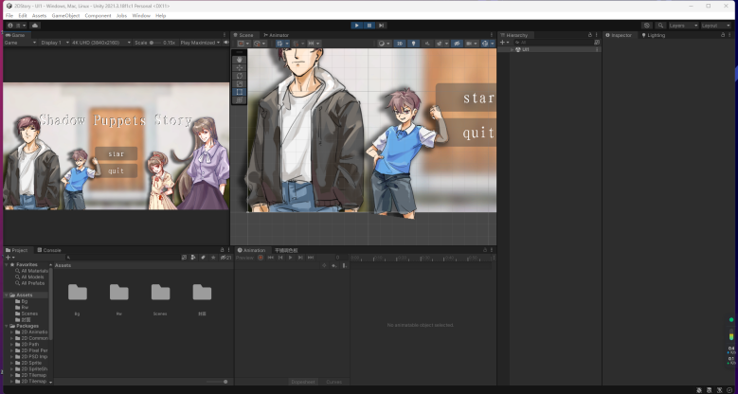

## Theme / Concept Art

In this e-book, it tells the story of a boy who goes to a press conference and meets a girl. He falls in love with her at first sight, so the boy asks for her contact information. Afterwards, the young and ignorant boy gathered the courage to invite the girl on a date, and thus they were together in an ambiguous atmosphere. After experiencing some minor frictions, they lived a happy cohabitation life. In the end, the boy and girl had a heart to heart connection and lived happily ever after.

In the story, I constructed a young and ignorant boy who is active, outgoing, ambitious, and responsible. He is an intelligent and shy girl. It is precisely because of the boy's responsible heart and the personality charm that he is deeply attracted to the girl. This book aims to show everyone that love is pure and beautiful, and one must love others seriously and responsibly.

## 1.6Concept Map

## 

## 1.7Evaluation

* Are you interested in the content of the story？
* Is this story easy to understand?
* Do you like the way this story is presented?
* Do you like the interaction style in the story?
* Is there a smooth reading process and any delay in interaction?
* Do you want to learn more stories with similar themes?
* Do you find the reading process dull and boring?

# Functional Specification

## User Interface

Developers believe that this concise page will provide users with a strong sense of experience. The main page is fully functional and eye-catching, and the night mode can facilitate users to watch at various time periods, greatly improving the customer experience. The silent mode is easy to understand and can be easily solved in any environment. The added feedback function allows developers to contact them as quickly as possible, and developers will make adjustments and changes as soon as they receive feedback. On the reading interface, the dynamic feedback method and 3D page flipping seem like reading a real book. The introduction's art style and button layout give people a refreshing feeling, improving the user's visual and physical operation experience.

## Storyboards

**Title**: Home Page **Frame ID**: *Home*

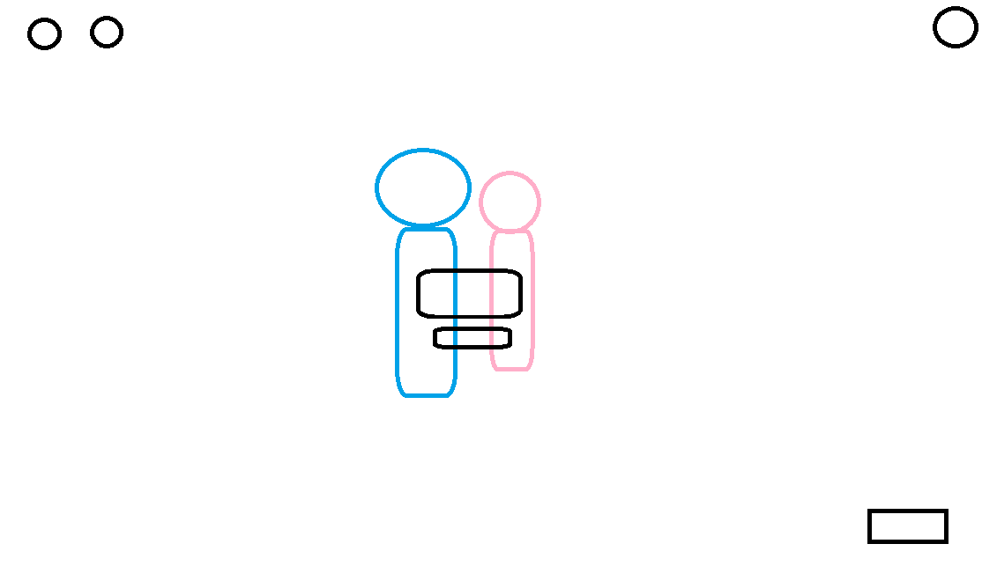

**Dimensions:**

1280*720 dpi

**Media Used:**

**SOUNDS**

**Atmosphere:** Light and cheerful music

**Music**: Relaxed, cheerful background music.

**Onclick:** For the user to interact with the button, the onclick event needs to have a click sound.

**Scene loading:** After clicking the "Start reading" button, continue playing background music, and switch to the next story page.

**FONTS：**The text emerges one by one.

**Buttons:**

* There is a "mute" button in the upper left corner
* There is a "Night Mode" button in the upper left corner
* There is a "Start reading" button in the middle
* There is a "reading mode" button in the middle
* There are "Chapter Catalogue" buttons on the side
* There is a "feedback" button in the lower right corner

**Background**:

A picture frame

**Content:**

A photo of the men and women

**Description (purpose / objectives):**

This is the most important part of the book, because here is the home page

**Animations:**

The hero and heroine will shake gently with the background music

**User Interactions Required:**

Click on different buttons to trigger different pages and click "Start reading" to read

**User Feedback:**

* Click "Start reading" will automatically jump to the first page
* Clicking "mute" will turn off all sounds
* Click "Night mode" to enter the night mode, and the brightness decreases
* Click "Reading Mode" to start the audio reading mode
* Click "Feedback" to email us

**Navigation / Links:**

Navigate to the storybook Home.

Navigate to the storybook Back.

Navigate to the storybook Next.

Navigate to the storybook State.

**Title**: Meet and know each other **Frame ID**: Page1

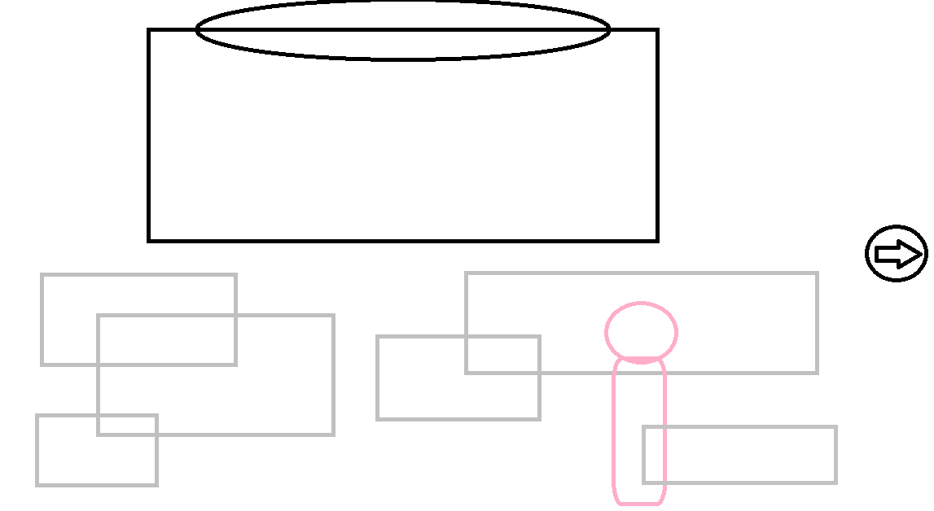

**Dimensions:**

1280*720 dpi

**Media Used:**

**SOUNDS**

**Atmosphere:** Light and cheerful music

**Music**: Relaxed, cheerful background music.

**Onclick:** The single-machine button will appear with a feedback prompt tone, such as "Ding Dong"

**Scene loading:** After clicking the "next" button, continue playing background music, and switch to the next story page.

**FONTS：**The text emerges one by one.

**Buttons:**

* Click the next (arrow to the right) to switch to the next page
* Click "(arrow to the left)" to switch to the previous page
* Clicking "mute" will turn off all sounds
* Click "Night mode" to enter the night mode, and the brightness decreases
* Click on Settings to open the Settings
* Click "Home page" to return to the home page

**Background**: The scene of a press conference

**Content:**

**Men go to attend a press conference, where accidentally saw she fell in love at first sight**

**Description (purpose / objectives):**

This is the first act of the story, and it is also the place where the men and women meet each other. The whole scene is described in a very simple style, and the art painting on the wall is the focus, which can imply from the side that the men and women will fall in love with each other. The overall content of the painting style is harmonious, giving people a feeling of immersive enjoyment.

**Animations:**

**The boy greeted the girl at the press conference**

**User Interactions Required:**

Click on different buttons to trigger different pages and Users need to click on the “Next”page to turn the page

**User Feedback:**

The Home page button helps the user to return to the home page. The Back Back button goes back to the previous scene. The Next Step page button can be moved to the next scene. The whole background music is relaxed and pleasant, giving people a comfortable feeling.

**Navigation / Links:**

Navigate to the storybook Home.

Navigate to the storybook Next.

Navigate to the storybook Back.

Navigate to the storybook State.

**Title**: First Date **Frame ID**: Page2

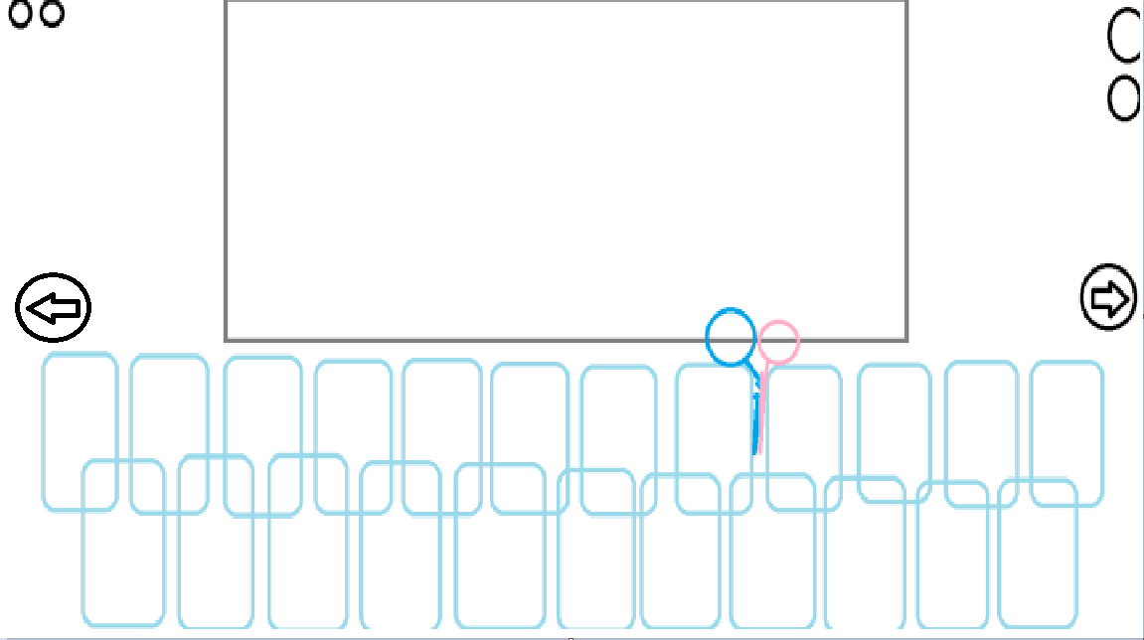**Dimensions:**

1280*720 dpi

**Media Used:**

**SOUNDS**

**Atmosphere:** Light and cheerful music

**Music**: Relaxed, cheerful background music.

**Onclick:** For the user to interact with the button, the onclick event needs to have a click sound.

**Scene loading:** After clicking the "next" button, continue playing background music, and switch to the next story page.

**FONTS：**The text emerges one by one.

**Buttons:**

* Click the next (arrow to the right) to switch to the next page
* Click "(arrow to the left)" to switch to the previous page
* Clicking "mute" will turn off all sounds
* Click "Night mode" to enter the night mode, and the brightness decreases
* Click on Settings to open the Settings
* Click "Home page" to return to the home page

**Background**: Dating at the cinema

**Content:**

**The first date, a boy confesses to the girl**

**Description (purpose / objectives):**

This is the second act of the story, which tells the story of the first date between the male and female protagonists. They watch a movie in the cinema, and when the ambiguous atmosphere reaches its peak, their confused hearts and friendship collide.

**Animations:**

* The movie is played behind the scenes
* Boys and girls watch the movies together

**User Interactions Required:**

Click on different buttons to trigger different pages and Users need to click on the “Next”page to turn the page

**User Feedback:**

The Home page button helps the user to return to the home page. The Back Back button goes back to the previous scene. The Next Step page button can be moved to the next scene. The whole background music is relaxed and pleasant, giving people a comfortable feeling.

**Navigation / Links:**

Navigate to the storybook Home.

Navigate to the storybook Next.

Navigate to the storybook Back.

Navigate to the storybook State.

**Title**: Happy cohabitation **Frame ID**: Page3

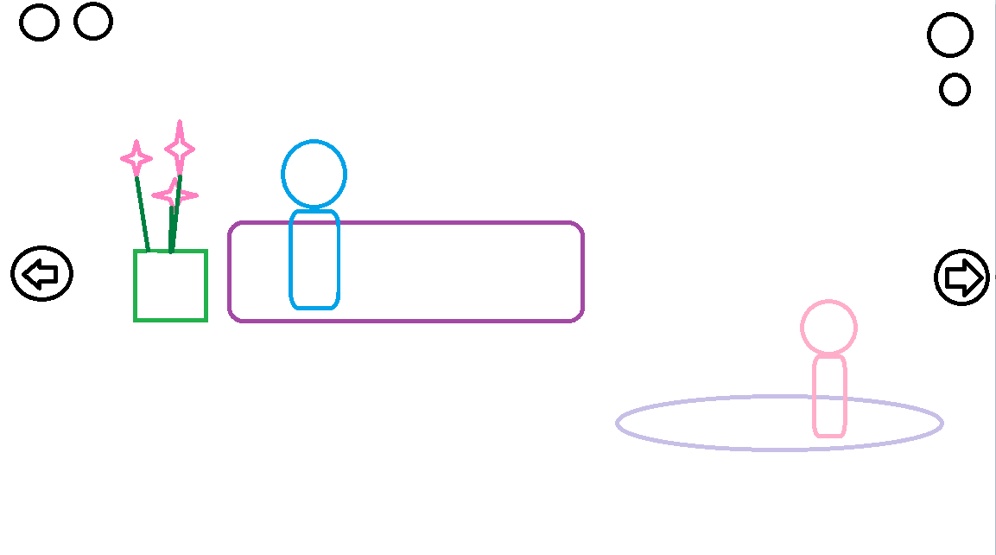**Dimensions:**

1280*720 dpi

**Media Used:**

**SOUNDS**

**Atmosphere:** Light and cheerful music

**Music**: Relaxed, cheerful background music.

**Onclick:** For the user to interact with the button, the onclick event needs to have a click sound.

**Scene loading:** After clicking the "next" button, continue playing background music, and switch to the next story page.

**FONTS：**The text emerges one by one.

**Buttons:**

* Click the next (arrow to the right) to switch to the next page
* Click "(arrow to the left)" to switch to the previous page
* Clicking "mute" will turn off all sounds
* Click "Night mode" to enter the night mode, and the brightness decreases
* Click on Settings to open the Settings
* Click "Home page" to return to the home page

**Background**:At home

**Content:**

**Boys and girls live happily together**

**Description (purpose / objectives):**

This is the third act of the story, after some twists and turns, the feelings of boys and girls are deeper, opening their happy cohabitation life.

**Animations:**

* The boy comforted the girl
* The girl was crying

**User Interactions Required:**

Click on different buttons to trigger different pages and Users need to click on the “Next”page to turn the page

**User Feedback:**

The Home page button helps the user to return to the home page. The Back Back button goes back to the previous scene. The Next Step page button can be moved to the next scene. The whole background music is relaxed and pleasant, giving people a comfortable feeling.

**Navigation / Links:**

Navigate to the storybook Home.

Navigate to the storybook Next.

Navigate to the storybook Back.

Navigate to the storybook State.

**Title**: Be together forever **Frame ID**: Page4

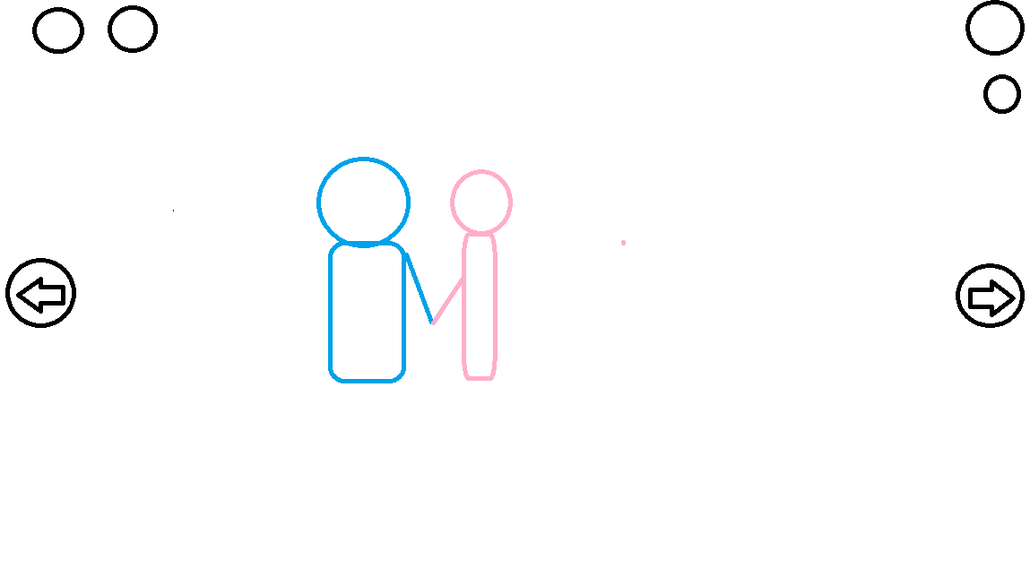

**Dimensions:**

1280*720 dpi

**Media Used:**

**SOUNDS**

**Atmosphere:** Light and cheerful music

**Music**: Relaxed, cheerful background music.

**Onclick:** The single-machine button will appear with a feedback prompt tone, such as "Ding Dong"

**Scene loading:** After clicking the "next" button, continue playing background music, and switch to the next story page.

**FONTS：**The text emerges one by one.

**Buttons:**

* Click the next (arrow to the right) to switch to the next page
* Click "(arrow to the left)" to switch to the previous page
* Clicking "mute" will turn off all sounds
* Click "Night mode" to enter the night mode, and the brightness decreases
* Click on Settings to open the Settings
* Click "Home page" to return to the home page

**Background**:The men and women are happily together

**Content:**

**Men and women hand in hand together to face the future**

**Description (purpose / objectives):**

This is the last scene of the story, after experiencing some ups and downs, the men and women more firmly choose each other, warm and generous to accept each other, together forever.

**Animations:**

The men and women embraced together

**User Interactions Required:**

Click on different buttons to trigger different pages and Users need to click on the “Next”page to turn the page

**User Feedback:**

The Home page button helps the user to return to the home page. The Back Back button goes back to the previous scene. The Next Step page button can be moved to the next scene. The whole background music is relaxed and pleasant, giving people a comfortable feeling.

**Navigation / Links:**

Navigate to the storybook Home.

Navigate to the storybook Next.

Navigate to the storybook Back.

Navigate to the storybook State.

**Title**: Ending **Frame ID**: End Page

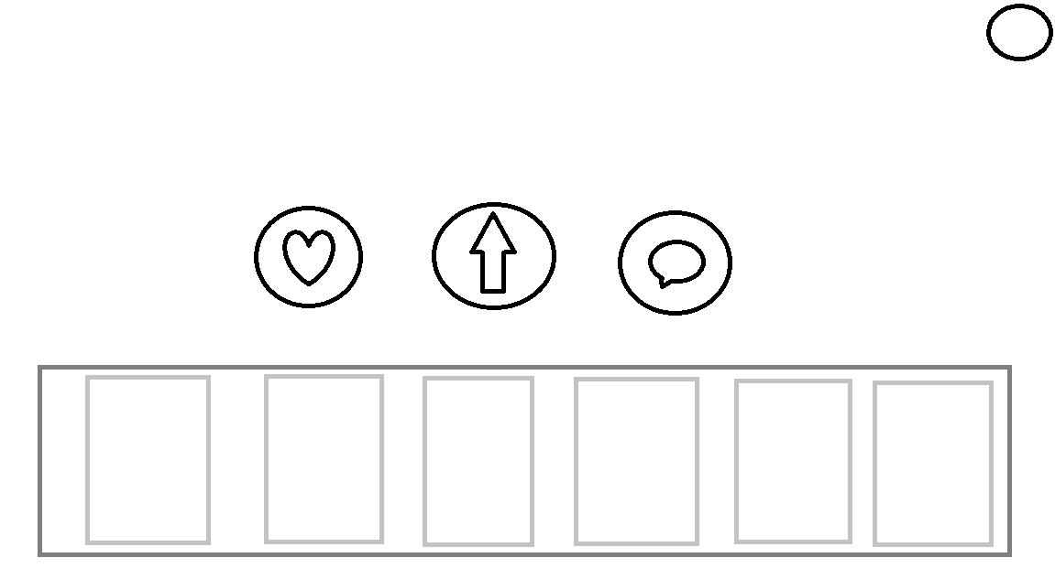

**Dimensions:**

1280*720 dpi

**Media Used:**

**SOUNDS**

**Atmosphere:** Light and cheerful music

**Music**: Relaxed, cheerful background music.

**Onclick:** The single-machine button will appear with a feedback prompt tone, such as "Ding Dong"

After clicking the "next" button, continue playing background music, and switch to the next story page.

**FONTS：**Straight jump

**Buttons:**

* **Click "Love" to like the collection**
* **Click "Up arrow" to return to the home page**
* **Click on "Text" to contact us for feedback**
* **Click "Recommended Books below" to automatically jump to the corresponding home page**

**Background**:The story homepage weakens the background

**Content:**

**Conclusion and other**

**Description (purpose / objectives):**

This is the end page of the story, where you can choose to return to the home page, like the collection, and contact us. If you are interested in our other books, you can click, then you will automatically jump to the corresponding home page

**Animations:**

Thank you for watching

**User Interactions Required:**

This is the end page of the story, where you can choose to return to the home page, like the collection, and contact us. If you are interested in our other books, you can click, then you will automatically jump to the corresponding home page

**User Feedback:**

This is the end page of the story, where you can choose to return to the home page, like the collection, and contact us. If you are interested in our other books, you can click, then you will automatically jump to the corresponding home page

**Navigation / Links:**

Navigate to the storybook Home.

Navigate to the storybook Feedback.

Navigate to the others storybook .

Navigate to the storybook State.

## Media

# *[*Technical specifications (optional)

Web page dimensions: 2400 x 915 pixels;

Horizontal banner: width 600 pixels x height 90 pixels;

Start button: 320 pixels x 50 pixels;

Next button: 320 pixels x 50 pixels;

Back button: 320 pixels x 50 pixels;

Home button: 320 pixels x 50 pixels;

# Media List/References (if required)

|  |  |
| --- | --- |
| Image name or description | Resource address/URL |
| **FONTS:** | [【Ps教程】故事书制作过程，Photoshop操作教程_哔哩哔哩_li](https://www.bilibili.com/video/BV1vJ41137H3/?spm_id_from=333.337.search-card.all.click)  [故事书展示动画AE模板_哔哩哔哩_bilibili](https://www.bilibili.com/video/BV1To4y1S7az/?spm_id_from=333.337.search-card.all.click&vd_source=d7a9b26570f972042ea3fa50a1660eee) |
| **IMAGE(ALL):** | [Unity2023新手入门教程_超细节100集课程_哔哩哔哩_bilibili](https://www.bilibili.com/video/BV1TZ4y1o76s/?spm_id_from=333.337.search-card.all.click) |
| **SOUND:** | Scenario 1: [星星在唱歌（网易云音乐2020听歌报告主题曲） - 司南 - 单曲 - 网易云音乐 (163.com)](https://music.163.com/" \l "/song?id=1807381939)  Scenario 2: [星星在唱歌（网易云音乐2020听歌报告主题曲） - 司南 - 单曲 - 网易云音乐 (163.com)](https://music.163.com/" \l "/song?id=1807381939)  Wave:[十七岁的夏天 (伴奏) - 钟易轩 - 单曲 - 网易云音乐 (163.com)](https://music.163.com/" \l "/song?id=562592259)  huge waves: [十七岁的夏天 (伴奏) - 钟易轩 - 单曲 - 网易云音乐 (163.com)](https://music.163.com/" \l "/song?id=562592259)  Scenario 5: [《等你下课》广播剧第一季主题曲《参数错误》 - 三刀dao - 单曲 - 网易云音乐 (163.com)](https://music.163.com/" \l "/song?id=1828149281) Bird calls: [http://music.163.com/song/1368600695?userid=629538667](http://music.163.com/song/1368600695?userid=629538667%20)  Scenario 6: [突然好想你 - 五月天 - 单曲 - 网易云音乐 (163.com)](https://music.163.com/" \l "/song?id=385781)  Scenario 7: [突然好想你 - 五月天 - 单曲 - 网易云音乐 (163.com)](https://music.163.com/" \l "/song?id=385781) |